Darshana pubudu keerthirathna

ICM 106 OR23106564

**DBMS IN-CLASS ASSIGNMENT 05**

**Question 01**

SELECT Customer.id, Customer.name, Orders.date, orders.amount

FROM Customer

INNER JOIN orders

ON

Customer.id=orders.Customer_ID;

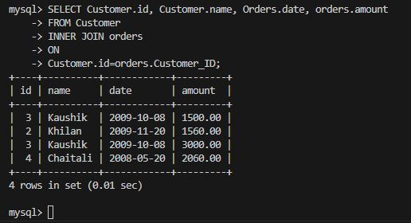

**Question 02**

SELECT Customer.id, Customer.name, Orders.date, orders.amount

FROM Customer

INNER JOIN orders

ON

Customer.id=orders.Customer_ID

WHERE orders.Amount > 2000;

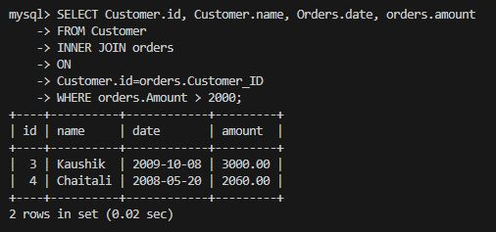

**Question 03**

SELECT Customer.id, Customer.name, Orders.date, orders.amount

FROM Customer

INNER JOIN orders

ON

Customer.id=orders.Customer_ID

WHERE orders.Amount = 3000;

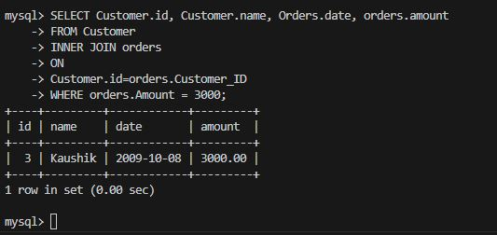

**Question 04**

SELECT Customer.id, Customer.name, Orders.date, orders.amount

FROM Customer

INNER JOIN orders

ON

Customer.id=orders.Customer_ID

WHERE orders.Amount BETWEEN 1550 AND 4000;

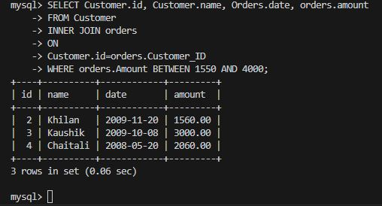

**Question 05**

SELECT Customer.id, Customer.name, Orders.date, orders.amount

FROM Customer

INNER JOIN orders

ON

Customer.id=orders.Customer_ID

WHERE Customer.Name = 'Kaushik';

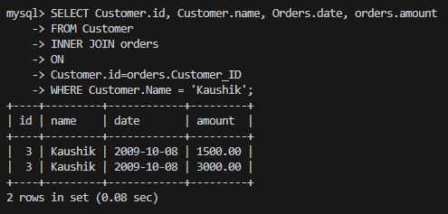

**Question 06**

SELECT Customer.id, Customer.name, Orders.date, orders.amount

FROM Customer

LEFT JOIN orders

ON

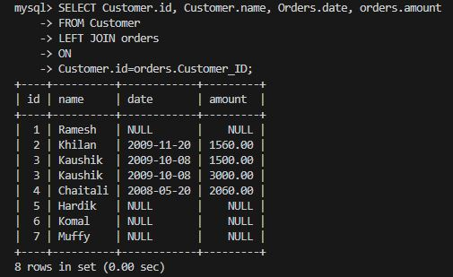Customer.id=orders.Customer_ID;

**Question 07**

CREATE TABLE Seller(

SellerID INT,

Seller_NAME VARCHAR(10),

code INT,

Order_ID INT,

CONSTRAINT PRIMARY KEY (SellerID),

CONSTRAINT FOREIGN KEY(Order_ID) REFERENCES Orders(OID)

);

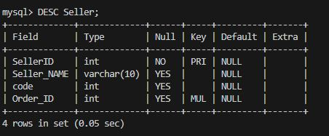

**Question 08**

SELECT Customer.id, Customer.name, orders.amount,Orders.date,Seller.Seller_NAME

FROM Customer

INNER JOIN orders

ON Customer.ID=orders.Customer_ID

INNER JOIN Seller

ON Orders.OID=seller.order_ID;

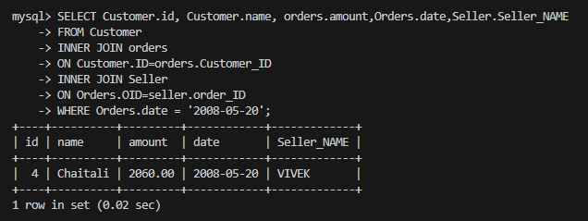

**Question 09**

SELECT Customer.id, Customer.name, orders.amount,Orders.date,Seller.Seller_NAME

FROM Customer

INNER JOIN orders

ON Customer.ID=orders.Customer_ID

INNER JOIN Seller

ON Orders.OID=seller.order_ID

****WHERE Orders.date = '2008-05-20';

**Question 10**

SELECT Customer.id, Customer.name, orders.amount,Orders.date,Seller.Seller_NAME

FROM Customer

INNER JOIN orders

ON Customer.ID=orders.Customer_ID

INNER JOIN Seller

ON Orders.OID=seller.order_ID

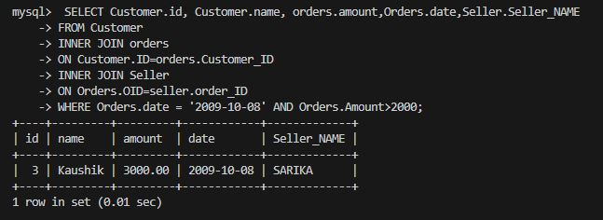WHERE Orders.date = '2009-10-08' AND Orders.Amount>2000;